Taking care of your waste water supply in Dunbar
Project reference
Horizons Dunbar Sewer Upgrade
This work is being carried out by Scottish Water’s commercial subsidiary, Scottish Water Horizons, and our deliver partner George Leslie
Address 1
Address 2
City
Postcode

18th June 2025

What we are doing
We have carried out investigations to the sewer network in your area and we now are required to conduct major upgrades to which we will need to conduct road closures within Pine St and suspend parking to operate safely.
When are we doing it
Work will begin in Pine Street on Mon 30 June and move along Pine Street in phases, lasting approx. 18 weeks.
What happens next

- Your water supply and drainage services from your kitchen and bathroom should not be affected by our work.
- We are required to close sections of Pine Street to all public vehicles during the dates above. (see overleaf) then work on Pine St in phases starting at number one, suspending parking as we move along. All five phases should be completed in approx. 18 weeks.
- Pedestrian access to properties within the road closure will be maintained, however parking within this area will not be permitted during our work.
- As we move from Phase 1 to 2, 3 etc we will lift the previous road closure onto the new phase. We will only operate one phase at a time, not all five simultaneously. Please follow all the signs put in place.

Thank you for your patience and understanding while we carry out this necessary work.

Alastair Kerr
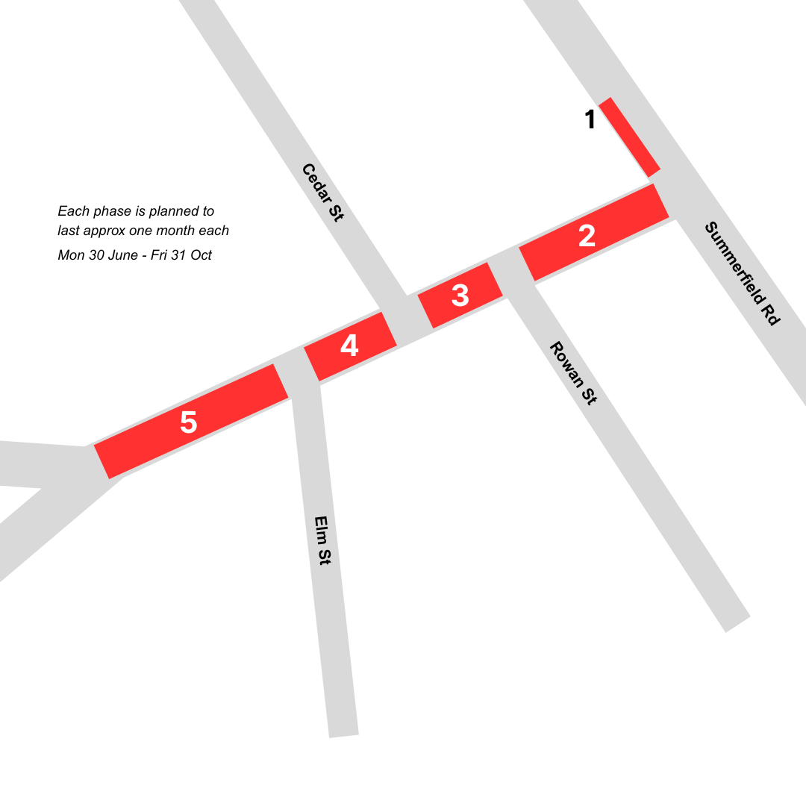
For illustrative purposes only

